WARD: Roosevelt 4th/15th

STATION: Science Demo/Experiments

OBJECTIVE: Help the boys have a fun, hands-on time learning about chemical reactions.

This station is about science fun! Talk with the boys about chemical reactions and allow them to participate in one or more chemical reactions themselves. What is done at this station beyond the requirement is up to you and/or your instructor. See how much safe, chemical fun you can have in 20 minutes.

Please have your experiments approved by your camp committee representative. Please bring a supply list to the April 23rd training. We will purchase all the supplies.

Webelos/AOL Elective Adventure: Adventures in Science

3. Complete the following:
g. With adult assistance, explore safe chemical reactions with household materials. Using two substances, observe what happens when the amounts of the reactants are increased.

(This might also be fun.)
e. Create two circuits of three light bulbs and a battery. Construct one as a series circuit and the other as a parallel circuit.

The following online resources might be helpful in planning this station:

http://www.education.com/activity/article/Foam_It_fifth/ (This is known as “elephant toothpaste” and is a great one!)

http://sadie423.hubpages.com/hub/hands-on-experiments-to-learn-about-chemistry

**Please do a 5 min. reflection at the end discussing the Scout Law point “Trustworthy” and how it goes with our theme and scripture.

WARD: Neola 2nd

STATION: Obstacle Course w/water features

OBJECTIVE: This station is to get the boys moving.

Please contact James Lemon. He will be in charge of this station. He will be asking some of the scouts in your ward to help with the operation of the course. Please contact him at 722-3015 to coordinate the help he will need. We also have a tug-o-war rope that can be used.
We want to add some water features to the course this year. You can use baby pools, slip-n-slides, water balloons or anything else you can think of to add to the course.

Webelos AOL Required Adventure: Stronger, Faster, Higher
1: Understand and explain why you should warm up before exercising and cool down afterward. Demonstrate the proper way to warm up and cool down.
2: Complete these activities and record your results: 20 yard dash, vertical jump, lifting a 5-pound weight, push-ups, curls, jumping rope (the course might include some of these).
Please bring a supply list to the April 23rd training. We will purchase all the supplies

**Please do a 5 min. reflection at the end discussing the Scout Law point “Brave” and how it goes with our theme and scripture.

WARD: Myton 1st

STATION: Human Foozball

OBJECTIVE: To have fun at camp

Webelos: Stronger, Higher, Faster

6: Try a new sport you have never tried before.

Webelos: Sportsman

2. Participate in two sports, either as an individual or part of a team.
3a. Explain what good sportsmanship means.
c. Give an example of a time when you experienced or saw someone showing good sportsmanship.

We will have a station leader training on April 23rd. We will purchase all the supplies.

**Please do a 5 min. reflection at the end discussing the Scout Law point “Cheerful” and how it goes with our theme and scripture.

WARD: Tridell

STATION: Stomp Rockets

OBJECTIVE: Fun with air rockets

We will have 4 launchers made and the paper to make the rockets. We are asking all the boys to bring a 2-liter bottle with the cap to camp. (See page 372-374 of the Webelos book to get familiar with the rockets and how they go together).

**See attached paper rocket templet.**

We will have a station leader training on April 23rd. We will purchase all the supplies.

**Please do a 5 min. reflection at the end discussing the Scout Law point “Helpful” and how it goes with our theme and scripture.

WARD: Neola 1st

STATION: Pinata Craft

OBJECTIVE: make a craft

Webelos: Art Explosion
4b. Display your artwork in a pack, school, or community art show.

Pick a mini pinata craft to make in 20 minutes. Here are some suggestions:
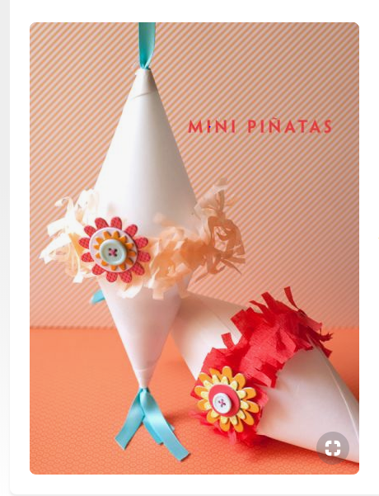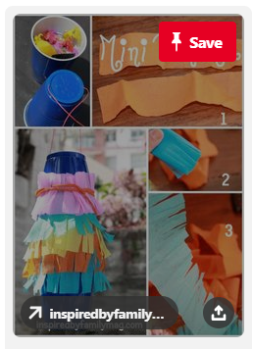

http://inspiredbyfamilymag.com/2012/09/21/diy-mini-pinata/

We will have a station leader training on April 23rd. Please bring your supply list with you to the training. We will purchase all the supplies.

**Please do a 5 min. reflection at the end discussing the Scout Law point “Obedient” and how it goes with our theme and scripture.

WARD: Roosevelt 5th/Randlett (please coordinate with each other)

STATION: Pre-Opener/Cracker Barrel (Clean)

OBJECTIVE: A snack the boys can eat throughout the day.

Please provide 6 people to help with the pre-opener. They will need to be there from 11:30am-1:00pm. Each boy will be given a bag of snacks they can have in there day bag to snack on throughout the day. The snacks will include popcorn, pretzels, honeycomb cereal, marshmallows, and M & M’s. We will also have measuring utensils so everyone get the same amount.

We will have a station leader training on April 23rd. We will purchase all the supplies.

WARD: Ballard

STATION: Hungry Hungry Hippos

OBJECTIVE: To expend energy and have fun!

This game will be a human size Hungry Hungry Hippo game played in the gym at the church building. Please get familiar with the normal size game rules and be prepared to play for 20 min. You can also play different rules (i.e. Each team must find all of one color or first team to 10 balls wins etc.)

We will have a station leader training on April 23rd. We will purchase all the supplies.
(4 scooters, 4 baskets, ropes, 40 soft balls (4 colors))

Webelos Elective Requirement: Sportsman

- Participate in two sports, either as an individual or part of a team.
- Complete the following requirements:
- Explain what good sportsmanship means.
- Role-play a situation that demonstrates good sportsmanship.
- Give an example of a time when you experienced or saw someone showing good sportsmanship.

**Please do a 5 min. reflection at the end discussing the Scout Law point “Loyal” and how it goes with our theme and scripture.

WARD: Roosevelt 2nd & Whiterocks

ASSIGNMENT: Flag Ceremony (Reverent)

Please do a patriotic flag ceremony for 5 minutes at Opening and Closing ceremonies. Please have your boys in uniform as much as possible. We have an American flag and a Utah state flag. We would like a little more than a regular flag ceremony. Make it special but simple and within the 5 minutes.

We will have a station leader training on April 23rd.

